Methods of Query Design

for Airdrop Datasets
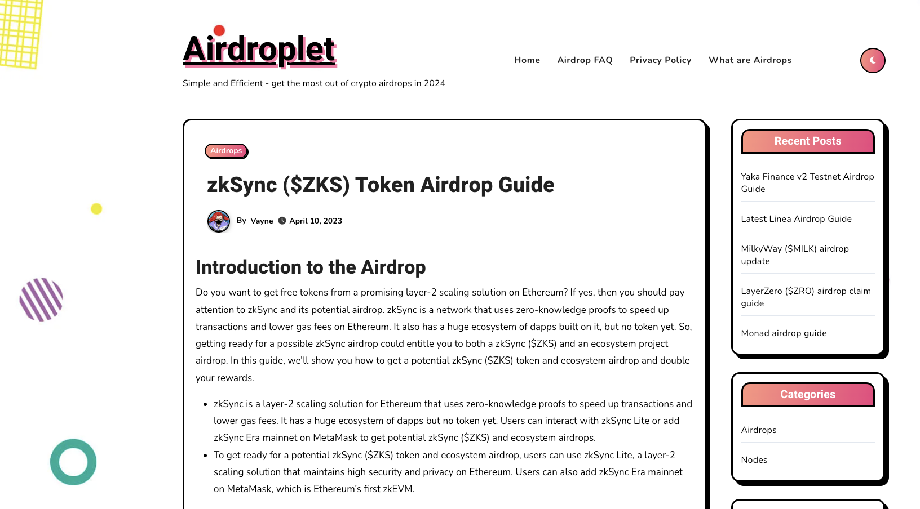
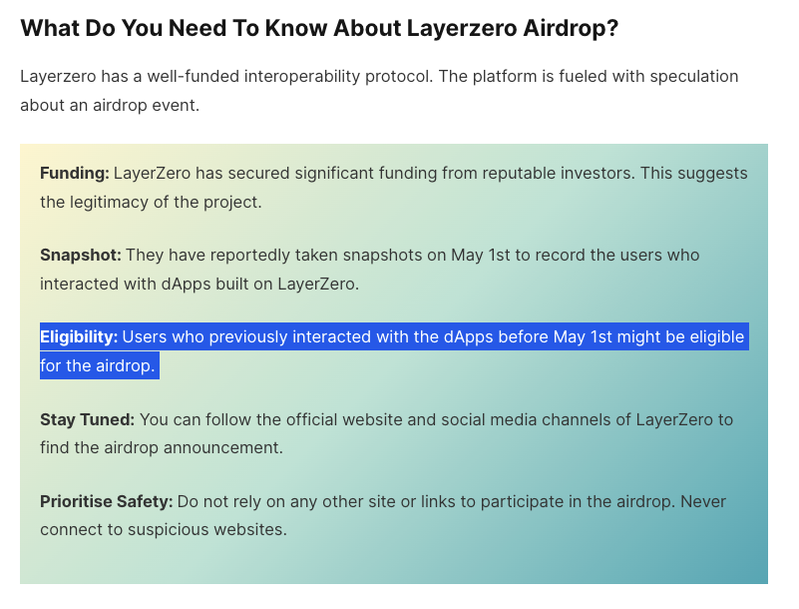
Source: https://www.biztechafrica.com/article/layerzero-airdrop/68157/
Table of content

About the list of airdrops 2
Telegram List-Making: Channels and Groups 4
Parameters for list-making 4
Where can we search for Telegram supergroups, gigagroups, and basic groups? 5
Telegram API 5
Search Telegram Groups 5
GPTs search engine for Telegram 5
Search Groups by Interests, Country or Language 5
Search telegram groups with Teleteg 5
Telegram Web Search filters 5
Repositories of Telegram 6
TGStat 6
Official channels of Airdrop projects 6
YouTube List-Making: Keywords and Digital Objects 7
✅How can we create a global sample dataset about airdrops? 8
Templates 11
ZKsync 12
Optimism (Time matters) 13
Airdrop #1 13
Airdrop #2 13
Airdrop #3 13
Airdrop #4 13
Celestia 14
Arbitrum 14
Taiko 15
Starknet 16
Polyhedra Airdrop #1 Binance Web3 Wallet Airdrop 05/02/2024 16
Polyhedra Airdrop #2 ZK Airdrop 12/03/2024 16
Twitter 16

About the list of airdrops

⛓️ 🪂 Relevant Airdrops for making lists of keywords & digital objects

Language: English

Location: North America, Europe, Asia (regions with high level of transaction engagement in blockchain)

All airdrops are from L2 layer, and they are used based on DappRadar ranking. They focus on scalability (descentralization).

See:
Farmer Friends
https://farmer-friends.gitbook.io/untitled/using-farmer-friends-bot
https://twitter.com/farmerfrens

NFT Copilot
https://nftcopilot.com/airdrop-farming
https://x.com/copilot_nft?lang=en

Sybil Samurai
https://sybil-samurai.gitbook.io/sybil-samurai/how./airdrop-reward-distribution
https://twitter.com/sybilsamurai

Telegram List-Making: Channels and Groups

Parameters for list-making
Include Telegram Channels and Groups named as or related to crypto airdrops. This is the list of relevant airdrops that this project aims to analyse:

⛓️ 🪂 Relevant Airdrops for making lists of keywords & digital objects
List making - Telegram & YT
Software for dataset building: 4CAT

Language: English
Location: North America, Europe, Asia

Telegram channels, supergroups, gigagroups and basic groups:

Feature | Basic Groups | Groups | Channels | Supergroups
Purpose | Small discussions | Discussions, teamwork | Broadcasting messages | Large communities
Member Limit | Up to 200 | Up to 200,000 | Unlimited | Up to 200,000
Who can post messages? | Everyone | Everyone | Admins/Editors only | Everyone
Publicly Searchable | No | No | Can be public with URL | Can be public with URL
View Count | No | No | Yes, for each post | No
Technical Details | Represented by chat constructors | Represented by chat constructors | Represented by channel constructors (broadcast flag set) | Represented by channel constructors (megagroup flag set)
Additional Features | None | None | None (unless public) | Admins, usernames, bots
Conversion | N/A | Can be converted to forums (split into topics) | Can be converted to gigagroups (limited posting, no limit on members) | Can be converted to forums (split into topics)
Source: https://core.telegram.org/api/channel. Table created with Gemini.

Where can we search for Telegram supergroups, gigagroups, and basic groups?
telegram_groups → sources/ query design strategy → “zksync airdrop” search queries: https://johnnatan-messias.github.io/pdf/resende_www2019_whatsapp.pdf https://dl.acm.org/doi/pdf/10.1145/3578503.3583603
We employed the query structure site: TELEGRAM_URL "zksync airdrop", where TELEGRAM_URL represented a combination of word-tokens such as t.me, telegram.me, telegram.org, and tg://join?invite.

Telegram API
https://core.telegram.org/api

Search Telegram Groups
https://www.telegram-groups.com/

GPTs search engine for Telegram
https://gptstore.ai/gpts/D6UMex5Z69-teleteg

Here are some Telegram groups and channels discussing various airdrops, including their names using "@" and the full URLs of the groups or channels:

Search Groups by Interests, Country or Language
https://www.telegram-groups.com/

Search telegram groups with Teleteg
https://teleteg.com/

Telegram Web Search filters
(open your Telegram Web and search for channels)

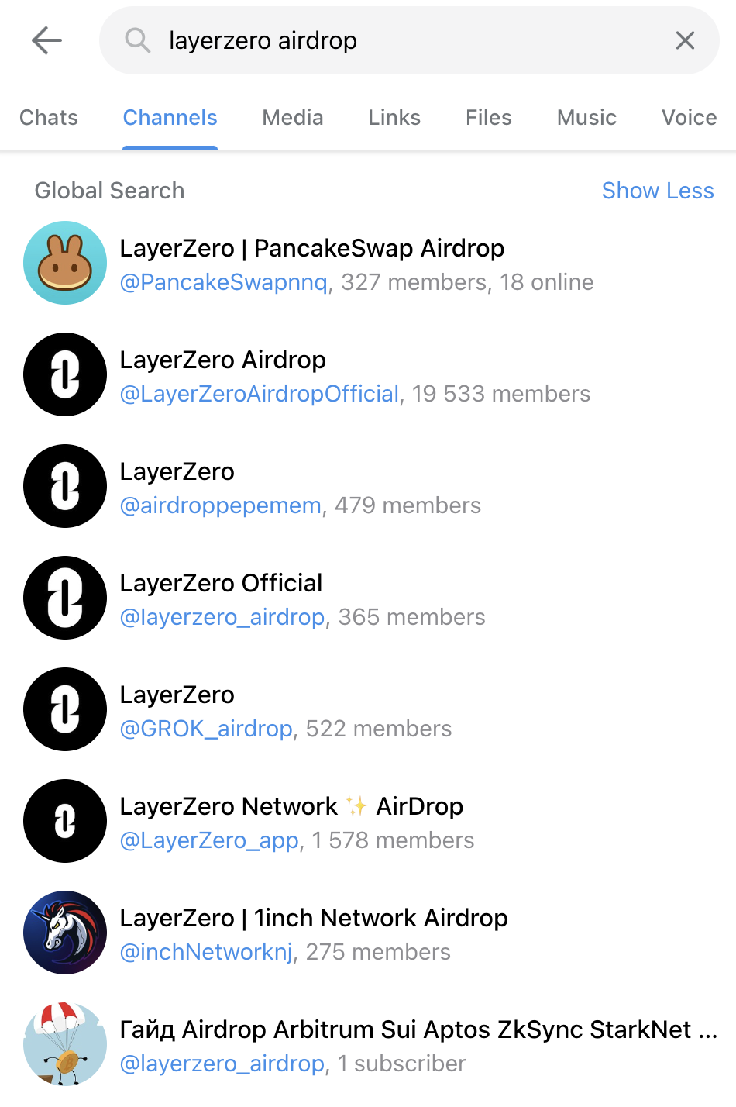

Repositories of Telegram
https://telemetr.io/en

TGStat
https://tgstat.com/

Example: Login in with Telegram Analytics Bot > search for Telegram channels and groups catalog >Cryptocurrencies > China > https://cn.tgstat.com/crypto > Search all channels and extract the links and info with Instant Data Scraper

Official channels of Airdrop projects
TBA

YouTube List-Making: Keywords and Digital Objects
⛓️ 🪂 Relevant Airdrops for making lists of keywords & digital objects
List making - Telegram & YT
Software for dataset building: YTDT (Rieder, 2015)

Language: English

Location: North America, Europe, Asia (regions with high level of transaction engagement in blockchain)
Blockchain attributes: https://github.com/matter-labs/zksync-data-dump/tree/main/data

✅How can we create a global sample dataset about airdrops?
https://bitnodes.io/nodes/live-map/
Chainalysis

Countries that stand out in investing on, adopting and or experiencing growing interest in blockchain, or countries where the ZKsync airdrop is popular.

United States (US), China (CN), Switzerland (CH), Singapore (SG), India (IN), Nigeria (NG), Vietnam (VN), Ukraine (UA), Brazil (BR), South Africa (ZA), Kenya (KE), Argentina (AR), United Kingdom (GB), El Salvador (SV), France (FX), Germany (DE), Japan (JP).

Countries

investing on Blockchain
United States
China
Switzerland
Singapore

where crypto adoption and investments have been on the rise:
India (The number of people “invested” in crypto more than tripled from 8% to 27% between 2018/19 and 2021/22¹.)
Nigeria (ranks among the countries with the highest crypto ownership, with almost 10% of its population owning crypto².)
Vietnam
United States

may also emerge as key players in the future
Brazil
South Africa
Kenya
Nigeria
Argentina

[copilot]
When it comes to blockchain technology and its adoption, several countries stand out globally. Here are some relevant ones:
- United States: The U.S. has been at the forefront of embracing blockchain technology¹. It actively explores various use cases and applications.
- China: Despite restrictions on cryptocurrency, China continues to experiment with blockchain-based services and advancements¹.
- Switzerland: Known for its crypto-friendly environment, Switzerland hosts numerous blockchain startups and projects¹.
- Singapore: Singapore is actively working on cross-border blockchain solutions to facilitate trade and combat trade finance fraud².
These countries have made significant strides in blockchain adoption and can be valuable additions to your list. Keep in mind that the landscape is dynamic, and other countries may also emerge as key players in the future. 🌐🔗
Let’s explore some countries where crypto adoption and investments have been on the rise:
- India: India has seen a significant increase in crypto users and owners. The number of people “invested” in crypto more than tripled from 8% to 27% between 2018/19 and 2021/22¹.
- Nigeria: Nigeria ranks among the countries with the highest crypto ownership, with almost 10% of its population owning crypto².
- Vietnam: Vietnam is another country experiencing growing interest in cryptocurrencies and blockchain technology.
- Ukraine: Ukraine has a vibrant crypto community, with increasing adoption and investment in digital assets.
- United States: While already established, the U.S. continues to witness crypto adoption, with various startups and companies actively participating in the industry³.
Remember that the crypto landscape is dynamic, and other countries may also emerge as key players in the future. 🌐🚀
When it comes to crypto adoption and blockchain technology in the global south, several countries have shown interest and growth:
- Brazil: Brazil has a growing crypto community, with increasing adoption and trading activity. The country hosts various crypto conferences and events.
- South Africa: South Africa has a vibrant crypto scene, with a rising number of users and exchanges. It’s one of the leading countries in Africa for crypto adoption.
- Kenya: Kenya has embraced mobile-based crypto solutions, such as peer-to-peer trading platforms. The country has a tech-savvy population interested in digital assets.
- Nigeria: As mentioned earlier, Nigeria ranks high in crypto ownership and has a thriving crypto ecosystem.
- Argentina: Argentina faces economic instability, which has led to increased interest in cryptocurrencies as an alternative store of value.
Remember that the global south is diverse, and other countries in this region may also contribute to the crypto landscape. 🌍🔗
https://x.com/arbitrum/status/1638163831833649152
https://twitter.com/TheZKNation/status/1800424206129357194
https://x.com/optimismgov/status/1664048963513896961
https://x.com/optimismgov/status/1638652104750567424
https://x.com/optimism/status/1760002821120983200
Expected for September 2024
https://x.com/starknetfndn/status/1757676598730342761
https://x.com/polyhedrazk/status/1770013173870903709
https://x.com/celestiaorg/status/1706671239572676881
https://x.com/taikoxyz/status/1793380651150016545

++++++++++++++++++++++
All airdrops are from L2 layer, and they are used based on DappRadar ranking. They focus on scalability (descentralization).

Airdrops profile:
- Forwards
- Backwards
- Not yet released

Airdrops reward structures:
- Future tasks (forward), task-oriented - from getting rich quickly to getting paid (maybe)
- Retroactive actions (backwards), uncertainty - from having faith and trust in the project to getting paid (maybe), e.g. LayerZero, Optimism, Taiko

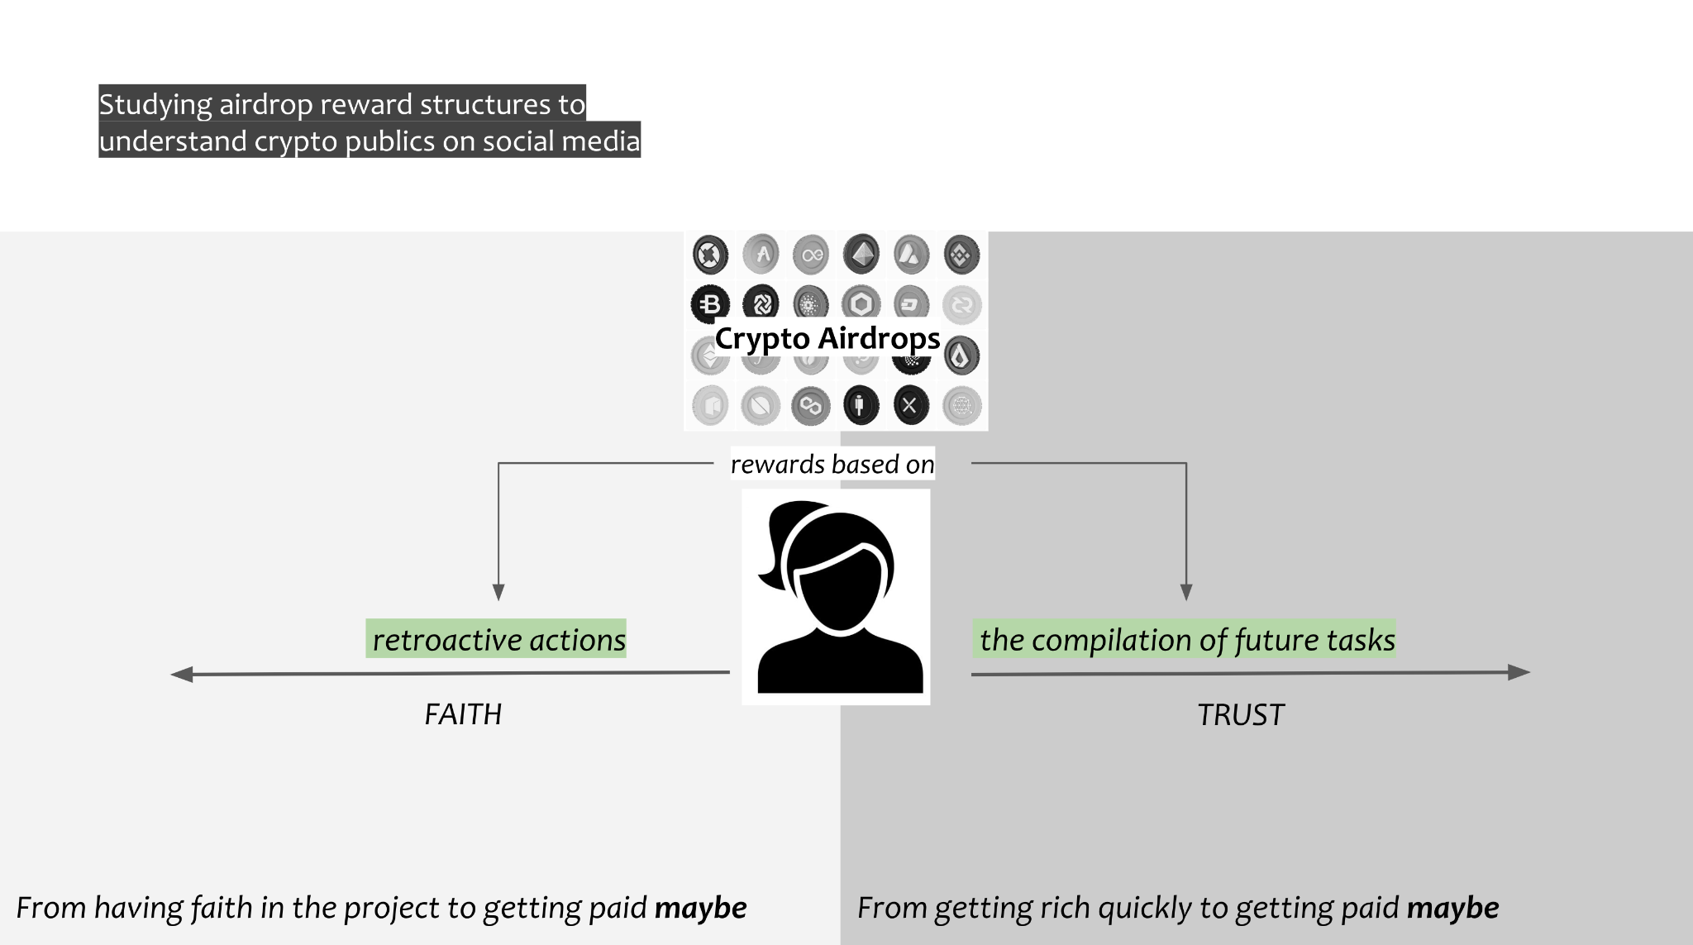

Definition of YT query design categories for building datasets:
- Airdrop itself (token typology, official announcement, white papers, projects that create credibility to attract users)
- Eligibility criteria (Selection criteria to earn the airdrop tasks, level of difficulty level, users, contributor)
- Distribution (e.g. ZKsync - 17.5% of the overall supply will be distributed through a one-time airdrop)
- Reward (types, e.g. ZKsync - Varies based on points earned and activity on ZKsyn; Optimism - Based on governance delegation, gas rebates, and additional attributes)
- Airdrop farmers and Sybil attacks

Templates
Airdrop itself
Eligibility criteria
Distribution
Reward
Airdrop farmers and Sybil attacks

Platform | Airdrop | Search query | Videos ids | Channels ids
YouTube | Ethereum | Airdrop itself  Airdrop ethereum ether, airdrop farming ethereum ether, easy crypto earning ethereum, zksync airdrop | [video ids here] | [channels ids here]
YouTube | Solana | airdrop solana sol, airdrop farming solana sol, easy crypto earning solana | [video ids here] | [channels ids here]
YouTube | Cosmos | airdrop cosmos atom, airdrop farming cosmos atom, easy crypto earning cosmos | [video ids here] | [channels ids here]

ZKsync
Airdrop itself

ZKsync airdrop, $ZKS airdrop, #zksyncairdrop

Eligibility criteria

Sort by relevance, date upload and rating:
eligibility criteria zksync airdrop, zkSync Airdrop Breakdown, zkSync Airdrop guide, How to be eligible for ZKSync airdrop, How to Qualify for zkSync Airdrop, zkSync Airdrop claim, zksync airdrop rewards

Video ids:
YGdhjTIQgLQ, 9iGNm981jzM, W9cS381mYGk, wtQpgmwVqXk, 1Y3pchYkZbo&t, l7iL66mc2ZU

Distribution
→ when searching for “zksync airdrop distribution” I found Sybil farming-related videos. E.g. k94pSm5Q7EY&t

Gas Limit used
https://github.com/matter-labs/zksync-data-dump/tree/main/data

https://www.ethernodes.org/countries
https://bitnodes.io/nodes/live-map/
https://ethernodes.org/

Reward
zksync airdrop rewards

Airdrop farmers and Sybil attacks
creating wallets for zksync airdrop, how to farm zksync airdrop, farming zksync airdrop, telegram bot zksync airdrop

Video ids:
mncRUYqG1Ko, 0r2pII2A35Y, qrU9xCq4PvU, yHiOK9fpicM, oK3Q7AAyitQ, a-G5-tEcr-0, 7QWAfHWZCek, Sgwl1MLWSPw, k94pSm5Q7EY

Underspecified:
how to farm airdrops, airdrop farming guide, airdrop farming system, airdrop farming, wallets for Sybil attack, manage multiple wallets, telegram bot airdrops

Avoid Blacklist with Sybil Wallets, Secret Way To Find Profitable Wallets

Optimism (Time matters)
Airdrop itself
#optimismairdrop,

Close relationship with binance: jJH5dkY-RM0

Eligibility criteria
eligibility criteria optimism airdrop, optimism airdrop guide, claim optimism airdrop

Airdrop farmers and Sybil attacks
optimism airdrop farming

XbmiHx4S1NY
Channel: AllThingsEVM

Airdrop #1

optimism airdrop 1

Video ids:
2 years before: bKVIfJIhS1o, FIKmlKWMdGg, UteGPQ9W2r0, BNrvq4VZmvw, Q9OYZruCLEY

1 years before: FQ7Zdu6Due4, ht1VUZ_fMqU,

Airdrop #2
optimism second airdrop
#optimismairdrop2
2nd optimism airdrop

Airdrop #3

optimism 3rd airdrop
#optimismairdrop3

Airdrop #4
#optimismairdrop4

PJDFwZ9JzDo,HIae-YbSdxk, FpSN885q2Rk

Celestia
Airdrop itself

Search query: celestia airdrop The Genesis Drop
Video id:
_NG06k3g7t8
trrLvsJOt00

Search query: celestia airdrop
Video id:
ecbwd7FrAqk
_XuhL5RnNE0
IwaSMByez4Q
17QIR-Smvqs
(most of the video about how to claim the airdrop/checking eleibility)

Eligibility criteria
Search query: the genesis drop eligibility criteria
UPPIkTCtyww

Search query: how to claim the Celestia drop 2023
Video id: whadM9v-cF4
17QIR-Smvqs
AC_8llLLGfM

Distribution
Reward
Airdrop farmers and Sybil attacks

Arbitrum
Airdrop itself
Arbitrum airdrop, $ARB airdrop, #arbitrumairdrop

Hashtag: https://www.youtube.com/hashtag/arbitrumairdrop

Arbitrum acronym: $Arb gives generally more ‘technical’ results, in particular prediction of prices and market analysis

[Query searched on video list module on YTDT, manual selection, co-tag network on]
yP96dkspUL8, VXqBvEeZEPo, NkHY6CKjidY, p2mi9BbTK74, 3Ym9gOEhp2w, AMYDEZU8nSY, XbmiHx4S1NY, R29DhCCZ_k8

Official announcement
Video id yP96dkspUL8

Search query: arbitrum airdrop
VXqBvEeZEPo

Eligibility criteria
Search query: how to claim arbitrum airdrop
NkHY6CKjidY
p2mi9BbTK74

Distribution (speculation on round 2)
Search query: after looking for distribution, YT returned results under the semantic space of ‘how to claim’
3Ym9gOEhp2w

Reward
Search query: arbitrum rewards (but also got derailed by some specific type of reward tokens which are not relevant to our conceptualisation of reward)
p2mi9BbTK74

Airdrop farmers and Sybil attacks
Search query: arbitrum airdrop farm*
AMYDEZU8nSY
XbmiHx4S1NY (also good for Optimism)
R29DhCCZ_k8

Taiko
Airdrop itself
Search query: Taiko airdrop
Video id:
jP1PiLjlWh0
xBGuwtw_8ng
JSquiaPCilY

Search query: #taikoairdrop

Eligibility criteria
Search query:
eligibility criteria Taiko airdrop
Taiko Airdrop Breakdown
Taiko Airdrop guide
How to be eligible for Taiko airdrop
How to Qualify for Taiko airdrop
Taiko Airdrop claim

Starknet
Airdrop itself
Search query: Starknet airdrop
Search query: #Starknetairdrop

Eligibility criteria
Search query:
eligibility criteria Starknet airdrop
Starknet Airdrop Breakdown
Starknet Airdrop guide
How to be eligible for Starknet airdrop
How to Qualify for Starknet airdrop
Starknet Airdrop claim

Polyhedra Airdrop #1 Binance Web3 Wallet Airdrop 05/02/2024
Airdrop itself
Search query: Polyhedra Binance Web3 Wallet Airdrop

Eligibility criteria
Search query:
eligibility criteria Polyhedra Binance Web3 Wallet Airdrop
How to be eligible for Polyhedra Binance Web3 Wallet Airdrop

Polyhedra Airdrop #2 ZK Airdrop 12/03/2024
Airdrop itself
Search query: Polyhedra ZK Airdrop

Eligibility criteria
Search query:
eligibility criteria Polyhedra ZK Airdrop
How to be eligible for Polyhedra ZK Airdrop

Twitter

Look at the official release announcements.

⛓️ 🪂 Relevant Airdrops for making lists of keywords & digital objects
List making - Telegram & YT
DMI24_blockchain-datasheet4datasets

North America: - North America, particularly the United States and Canada, has been a significant hub for blockchain development and adoption. - Key Factors: - Tech Ecosystem: North America hosts major tech hubs (e.g., Silicon Valley) where blockchain startups thrive. - Financial Centers: Major financial centers (e.g., New York) drive blockchain adoption in finance. - Regulatory Environment: Clearer regulations encourage blockchain projects. - B2B Cross-Border Transactions: North America is a leader in B2B cross-border blockchain transactions¹. - Europe: - Europe has a strong presence in blockchain technology. - Key Factors: - Blockchain Hubs: Cities like London, Berlin, and Zurich foster innovation. - Collaboration: European countries collaborate on cross-border projects. - Blockchain Research: European universities contribute to blockchain research. - B2B Cross-Border Transactions: Europe ranks second in B2B cross-border blockchain transactions¹. - Asia: - Asia, especially China, has been at the forefront of blockchain adoption. - Key Factors: - Government Support: China’s government actively promotes blockchain. - Tech Giants: Asian tech giants (e.g., Alibaba, Binance) drive adoption. - Crypto Trading: Asia dominates crypto trading volumes. - B2B Cross-Border Transactions: Asia is a significant player in B2B cross-border blockchain transactions¹. Conversation with copilot, 2 July 2024.
North America: - North America, particularly the United States and Canada, has been a significant hub for blockchain development and adoption. - Key Factors: - Tech Ecosystem: North America hosts major tech hubs (e.g., Silicon Valley) where blockchain startups thrive. - Financial Centers: Major financial centers (e.g., New York) drive blockchain adoption in finance. - Regulatory Environment: Clearer regulations encourage blockchain projects. - B2B Cross-Border Transactions: North America is a leader in B2B cross-border blockchain transactions¹. - Europe: - Europe has a strong presence in blockchain technology. - Key Factors: - Blockchain Hubs: Cities like London, Berlin, and Zurich foster innovation. - Collaboration: European countries collaborate on cross-border projects. - Blockchain Research: European universities contribute to blockchain research. - B2B Cross-Border Transactions: Europe ranks second in B2B cross-border blockchain transactions¹. - Asia: - Asia, especially China, has been at the forefront of blockchain adoption. - Key Factors: - Government Support: China’s government actively promotes blockchain. - Tech Giants: Asian tech giants (e.g., Alibaba, Binance) drive adoption. - Crypto Trading: Asia dominates crypto trading volumes. - B2B Cross-Border Transactions: Asia is a significant player in B2B cross-border blockchain transactions¹. Conversation with copilot, 2 July 2024.

